The College Library is very pleased to announce that our third guest for 2014 is none other than
Academy Award winner Adam Elliot - animator, photographer, writer, director and of course the filmmaker responsible for the brilliant short film Harvie Krumpet (2003) and the feature length Mary and Max (2009).
Adam has made 5 films to date and collected numerous awards for his innovative, humorous and often challenging works, including an Oscar for Harvie Krumpet and the Annecy Cristal prize for Mary and Max.
Adam will be appearing live at Lyndale Library on 15 May at 10.15am.
Entry is free of course, but Bookings are essential.
*Reserve your seat(s) by contacting Mary Koutras or Andy McLuckie c/o College Library.

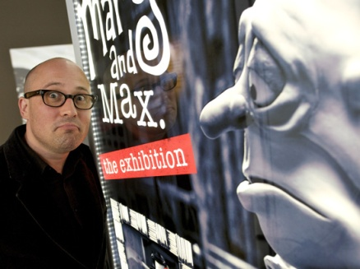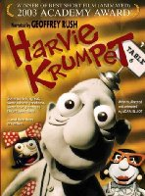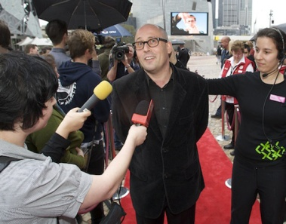
After completing his Year 12 Adam spent five years hand-painting tee-shirts at the St Kilda, Victoria Esplanade Craft market.
In 1996 Adam completed a Post Graduate Diploma in Film and Television, specializing in animation at the Victorian College of the Arts. There he made his first stopmotion film, Uncle, which won numerous film awards and participated in various international and local film festivals.
In collaboration with the Australian Film Commission, Screen Australia, Film Victoria and SBS, Adam made three more short films: Cousin, Brother, Harvie Krumpet, and his first feature Mary and Max. Adam is currently writing and developing his next feature.
Adam Elliot was born in Berwick, Victoria, in 1972. A shy but creative child, Adam was constantly drawing and making things out of found objects.
Adam attended the Pinewood Primary School in Mount Waverley then Hailebury College, Keysborough, where he developed an interest and proficiency in Art, English literature, Photography, Drawing and Sculpture.
Adam also took up acting and in his final year was awarded the school's highest honour, the A.G. Greenwood Trophy for an outstanding dramatic performance as Dr. Watson in the Sherlock Holmes play The Incredible Murder of Cardinal Tosca.
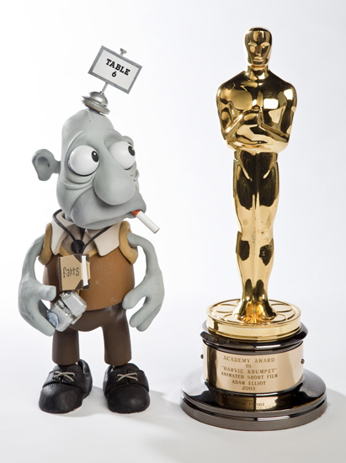

Biographical text above is an edited version from the following webpage: http://tinyurl.com/oo8wgaa
Pictures courtesy of ACMI: http://tinyurl.com/m3x663k

The images in this article are copyright and should only be distributed for educational informational purposes. A. McLuckie 2014

