THE BUZZ Library Newsletter edited by A. McLuckie

Term One 2014 Issue 1
In this newsletter, the first of a quarterly series of publications which will inform readers of the diverse range of projects and activities the library is involved in this year we begin by extending a warm welcome to Mary Koutras who has joined us as library manager. Welcome Mary!

Coming Attractions
Jan will be performing his special ‘Lest we forget’ show in the College Library on ANZAC Day eve during periods 3 and 4 ahead of the public holiday on Friday.
All year 7 teachers are cordially invited to attend. Other staff members who would like to attend are most welcome but please email Andy McLuckie first as seating will be limited.
mcluckie.andrew.a@edumail.vic.gov.au
On the 24th of April the College Library will host the first of a number of special events for 2014.
We are very pleased to announce that our first guest for the year will be Jan (Jarn) Wositzky, musician, storyteller and former singer with the legendary Bushwackers Band. For more details see: http://www.janwositzky.com.au/
Jan is coming to Lyndale to perform two shows for our year seven students.

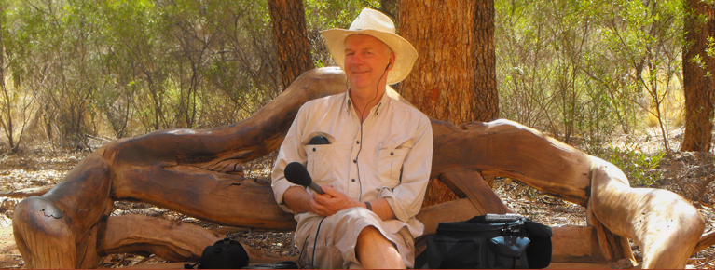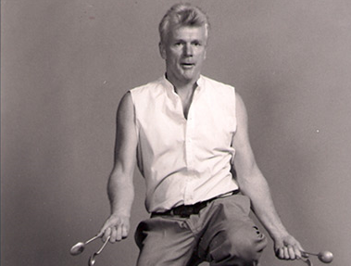

New clubs for Lyndale students
The College Library is in the process of exploring and developing stimulating extracurricular activities for Lyndale students. Two areas of interest to us at present include the establishment of a Library Book Club involving the parents and family members of our students (including ‘virtual’ membership via the Book Club blog on the Library Website) and a Film Club that will provide students with the opportunity to develop their knowledge of cinema and filmmaking by watching films and participating in a range of filmmaking processes.
We will announce the details of Book Club when we finalise the details, but for now I’d like to say a few words about Film Club and ask Lyndale staff for your support during the early ‘promotional’ stages of the club.
Firstly, what is Film Club?
At this stage we anticipate that Film Club will be a once a week after school club where members can watch films, discuss films and learn about many aspects of filmmaking including:
- Writing screenplays, cinematic storytelling
- Film production: cinematography, lighting and sound, music & soundtracks, film editing etc.
- Producing and directing films
- Great and influential filmmakers and much more...
Film Club members will have the opportunity to participate in the production of several short films which will be entered in the My Story My Content Short Film Competition. The theme this year is ‘how films can make a difference to our lives and to the world we inhabit. See: http://mystorymycontent.com/about/
Film Club will aim to be much more than a film appreciation group. Yes, we will view some great films but Film Club will also be about tapping the creative skills of our students across wide range of areas.
How can I help I hear you say?
In coming weeks, Film Club will be promoted via the school newsletter, the library website www.lyndalelibrary.org etc. However, I would appreciate it if teachers would help me publicise Film Club early in term 2 by handing out some informational bookmarks during form assembly. Also if you know of any students who may have what it takes to be the next Spielberg we would love to sign them up now. Finally, if you would like to help me run Film Club or contribute to the club in some way I would love to hear from you ASAP. All enquiries at this stage to Andy McLuckie- emails are fine.

Library Website Update
The library website is currently undergoing a significant upgrade. In addition to providing students, staff and parents with access to a greater range of educational resources and library services we will be increasing the capacity for all our stakeholders to interact with library staff. This interaction may take the form of communicating with us through the new Film Club or Book Club blog; it may be in the form of a request to purchase a particular book or to recommend a book or event that would be of interest to members of the school community. The very talented Samantha Weerasinghe, (better known to us all as Sam), is helping with the upgrade.
The upgrade will make use of HTML5 – the latest iteration of hyper text mark up language (HTML). The switch to HTML5 will allow faster creation and editing of our website content so we can keep our website looking relevant and fresh. We will keep you posted when the new website rolls off the line…
Reconfiguration of Library Layout
The Library is changing its internal layout to make the space adaptable to a range of new priorities. For example, the desks and computers that run down the centre of the library will be moved to open up the main space and provide (movable) seating to accommodate visiting speakers and performers.
Library Opening Hours
From Mon 24/3 the library will be open to students for private study during recess - no passes are required.
For the record the College Library is now currently open to students
- Before school 8am – 8:30am
- Recess to 10 to 10:20 (private study/quiet reading)
- Lunch 1pm to 1:40pm
- After school 3pm to 4pm.
BUZZBIZ - with Mary

Dear students, parents and staff
I’m sure most students and staff have seen me in the library but allow me to introduce myself.
My name is Mary Koutras and I am new to Lyndale Secondary College. Although new to this school I bring with me over 20 years of Library experience, including working in university libraries, public libraries and other school libraries.
Feel free to approach me if in need of any library assistance. I, along with Mr. McLuckie and Ms Vander Werf are always available to assist you and to make sure that your Library experience is a positive one.

BUZZBIZ cont...

You will start noticing some changes taking place in our Library Resource Centre. We hope that these changes will enhance the overall appearance and perception of the library and be more inviting for you guys to want to visit us more often.
We will constantly be purchasing new books throughout the year to build our library collections and have you up to date with some of the latest bestsellers. Feel free to peruse our New Book display. Modern, funky and sleek, it will cause quite a buzz ! (See below)
If you have any book requests you would like to have added to our collection, please do not hesitate to let the library staff know. A Graphic Novel and Senior Fiction Collection will be introduced in the coming weeks.
A Television has been installed in our library. This will help keep you informed of day to day activities and messages from the school as well as informing you of up and coming surprises that are being planned.
Surprise Number 1
In term 2 we will welcome an Academy Award winner to our library as a guest speaker. This is something you will not want to miss! Stay tuned…..
Ms Koutras
Library Manager

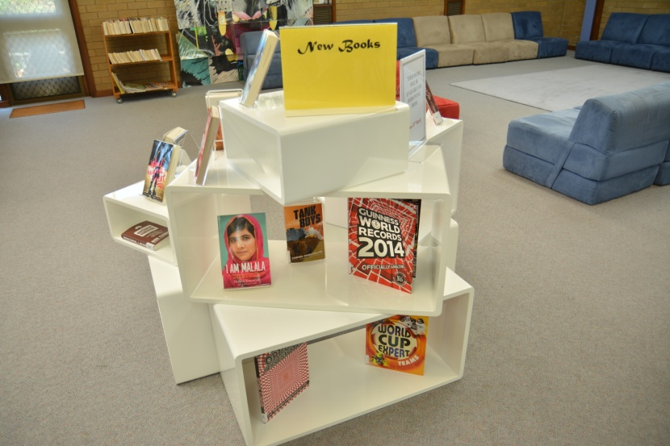
New Books display unit

