The Lyndale Secondary College Library is pleased to announce that our fifth guest speaker for this year and our first guest for Book Week will be author Archimede (Archie) Fusillo.
Archie will be coming to Lyndale Secondary College on Wednesday, 20 August for two presentations to be held during periods 2 & 3 in the College Library.
It is expected that Archie will be talking mainly to our year 8 and 9 students but all staff are most welcome to attend. If you would like to see Archie’s presentation in the College Library in Term 3, please reserve your seat by contacting Mary Koutras or Andy McLuckie ASAP as bookings are essential.

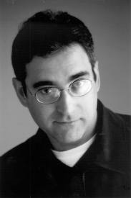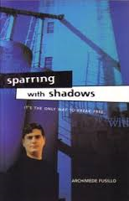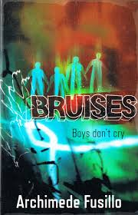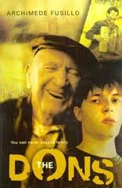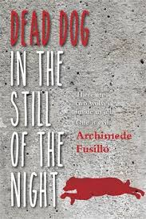

About this book Archie says, "I have tried to show that boys do have emotions, are vulnerable, and that it is acceptable to express their feelings”. Sparring with Shadows was listed as a Children's Book Council Notable Book.

Archie's second novel for teenagers, The Dons, was published in 2001. He has also written four stories for younger readers, Let it Rip! Game or Not, Bragging Reggie and The Great Switcheroo, all part of the popular Aussie Bites series

Other titles include: An Earful of Static, Uncorked and Grandad's Phase, a picture book illustrated by Terry Denton.
His most recent books for young adults are: Last of the Braves, Bruises and On the Mat.
He now writes full-time but he also travels widely, conducting writing workshops for school students and for adults in various community based projects. As he says,
"Writing should be fun, never a chore, even if the craft of writing itself demands discipline and application."
Archimede (Archie) Fusillo, the son of Italian migrants, was born and grew up in Melbourne. Surrounded by wonderful storytellers, he learnt early on the value of stories in shaping our lives and connecting people, irrespective of backgrounds.
Archie studied at Melbourne Uni and since then has worked as a secondary school English Teacher in Victoria, where he was nominated by his students for the Victorian Teacher Excellence Awards.
Archie's first novel for teenagers, Sparring with Shadows, was published in 1997 to great critical acclaim. The story, while not autobiographical, draws on his own experiences growing up in an Italian family in Melbourne.

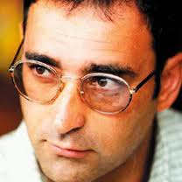

Biographical information above is sourced from The Literature Centre website: http://www.thelitcentre.org.au/author/archie-fusillo Compiled and Edited by A.McLuckie 2014

