The Buzz…Lyndale College Library News
Well we’ve been hearing for some time that “winter is coming” and it seems that it is now finally upon us. But cold weather alone does not explain the dramatic increase in students attending the College Library during recess and lunchtimes. We have been consistently attracting 50 to 60 students during lunchtime for months now and recess has been equally well patronised. Increased numbers are great, but the more encouraging thing for us as educators is that a very high proportion of the students that make up these numbers are working diligently on tasks assigned to them by their various teachers. Student behaviour has been outstanding and the library is clearly becoming the preferred location for a range of Lyndale student’s intent on making the most of the time they spend at their school.
ANZAC Day 2016 Commemoration.
On Friday, 22 April, the Lyndale Library Guest Speaker Program presented actor Geoffrey W. Graham and his show Voices of War: an ANZAC Story. The show, a combination of music, verse, comedy and drama featuring impromptu performances by some of our students, focused on the central themes of ANZAC: mateship and courage, hardship and sacrifice, humour and national identity.
Voices of War was attended by around 200 students and staff and some great book prizes were awarded to students for coming up with interesting questions at the end of the formal presentation.
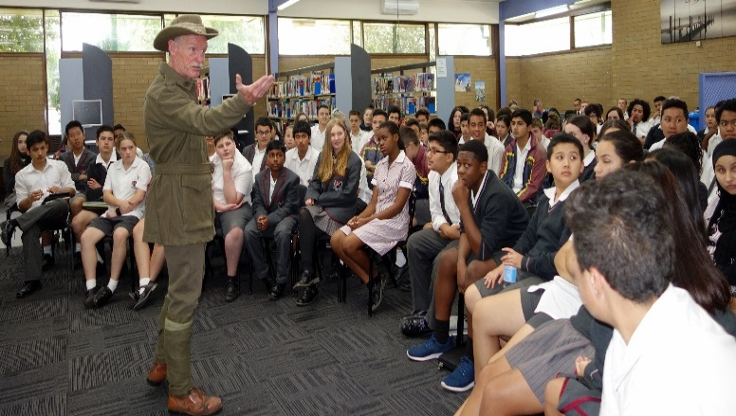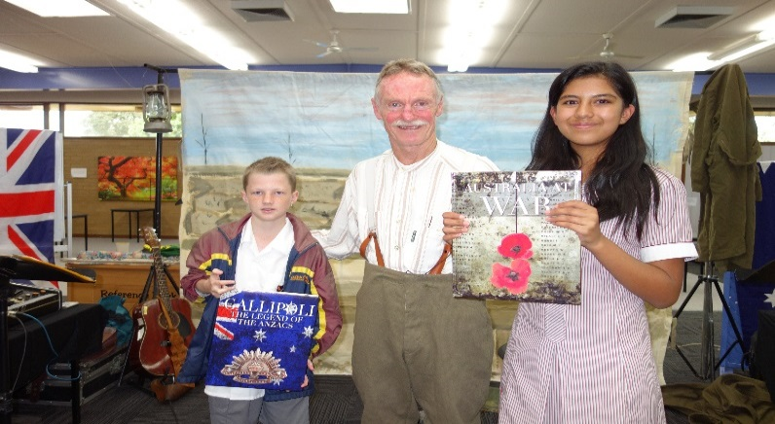
Geoffrey W. Graham presents Voices of ANZAC Lyndale student’s with their ‘best question’ prizes
Coming Attractions…
A quick plug also for Miss Madison Stewart aka ‘Shark Girl’ who will be the next guest presenter in our 2016 program. Madison an energetic, globetrotting, 22 year old underwater filmmaker who has dedicated a sizable portion of her young life to the preservation of marine environments including the Great Barrier Reef will be speaking to our students and showing excerpts from her films in the College Library on Thursday, 2 June.
We will give away several signed copies of Madison’s latest film ‘Shark Girl’ as prizes for the best questions of the afternoon. The presentation is fully booked, but to read more about Madison Stewart our second guest speaker for the year, see the promo poster in this edition of The Falcon.
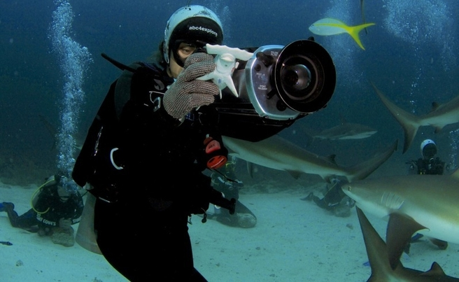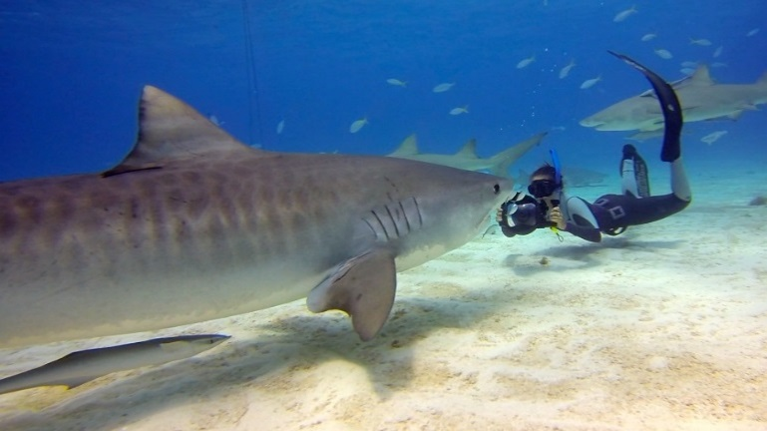
The intrepid Shark Girl, Madison Stewart at work in the open sea!
Text: Andy McLuckie, Teacher-Librarian. Pictures Mary Koutras, Library Manager. For details of all our past presenters and much more, pay us a visit online @ http://www.lyndalelibrary.org/

