Mother’s day

In honour of Mother’s day, the Library invites Lyndale students to participate...

Find/create an image that demonstrates the love you have for your mum, or any significant female in your life.
An example - a collage of photos of you and your mum together.

Then tell us in 50 words or less what your mum/female figure means to you and why? Be unique, creative, make it funny, different, make it a winning reason.

Prizes awarded to top 3

Competition closes on 25th May
Winners announced 27th May
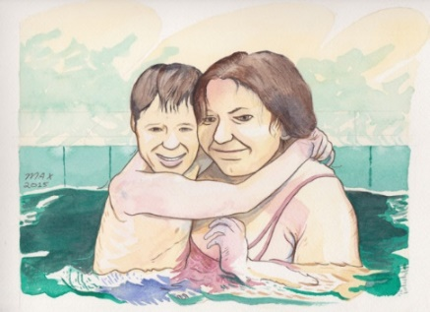
Email your entry to:
lyndalelibrary@gmail.com
*Don’t forget to attach the image/photos.

