Lyndale College Library Guest Speaker Program presents Isobelle Carmody, Tues, Aug 18, 2015.
Venue: LSC Library, Period Two commencing 10.30am Bookings are essential
Isobelle Carmody began the first of her highly acclaimed Obernewtyn Chronicles while she was still at high school and worked on it while completing a Bachelor of Arts and then a journalism cadetship. The first book was accepted by the first publisher she sent it to and went on to be short-listed in the Older Readers section of the Children’s Book Council Book of the Year Awards. The series and her short stories have established her at the forefront of fantasy writing in Australia.
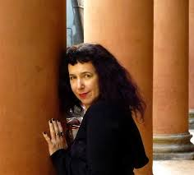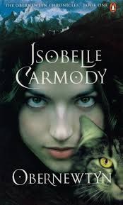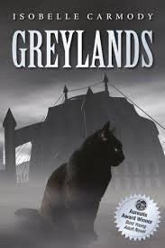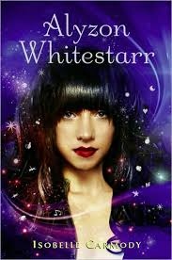
Isobelle has written many award winning short stories and books for young people since then. Greylands was named a White Raven at Bologna Book Fair and the title story of the Green Monkey Dream Collection won Best short story in the Aurealis Awards when it was published. Darksong won an Aurealis Award in its year. Alyzon Whitestarr won a Golden Aurealis when it was published.
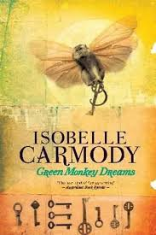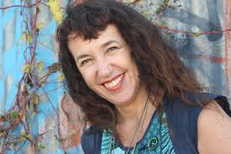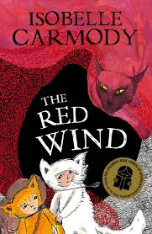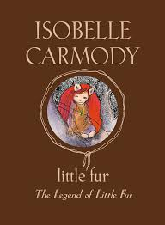
The Legend of Little Fur was Isobelle’s first series for younger readers. She illustrated this and the other three books that completed this series herself with pen and ink drawings. The Red Wind, the first book in The Kingdom of The Lost series which she also illustrated, won the CBC Book of the Year in 2011 in the Younger Readers’ Category and its sequel, The Night School illustrated by Anne Spudvilas, was shortlisted for an Aurealis Award in 2011. The Cloud Road, was shortlisted for the Aurealis Awards for Best Children’s Book in 2013.
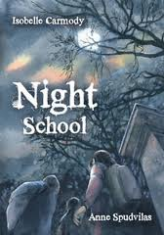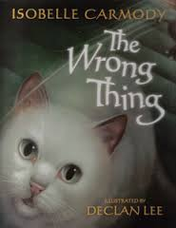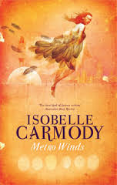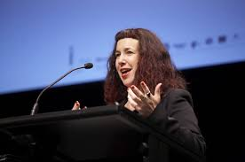
Metro Winds, Isobelle’s latest short story collection was published in May 2012. (Metro Winds and many others are available for loan from the college Library). Isobelle is currently working on The Red Queen, the final book in the Obernewtyn Chronicles, and the screenplay for a film treatment of her book Greylands. She has also begun a PhD at the University of Qld.
The text above is an edited extract from http://www.isobellecarmody.net/ Images used on this page are copyright of the owner and are reproduced here solely for the promotion of a single, non-profit educational event at Lyndale Secondary College. Compiled by A. McLuckie, (2015).

